

STUDENT GRADE SORTER

Course | Computer Organization & Assembly Language
Submitted By | Huzaifa Ali, Fasihullah
Roll No. | 242277, 233138
Submitted To | Ms. Seemab Khan
Date | 30 May 2026

Department of Creative Technologies

1. Project Title and Objective
Project Title | Student Grade Sorter
Language | x86 Assembly (MASM)
Library | Irvine32
Platform | Windows 32-bit Console Application
Project Type | Course Project — Computer Organization & Assembly Language

Objective
The main objective of this project is to build a fully functional student grade management system written entirely in x86 Assembly language using the MASM assembler and Irvine32 library. The program accepts student names and scores as live input from the user, sorts them in ascending or descending order using Bubble Sort, and then produces a detailed report that includes individual grades, statistics (highest, lowest, average), and a complete grade distribution breakdown.
This project demonstrates real-world use of fundamental assembly concepts including register management, memory addressing, procedure calls, looping constructs, string handling, and conditional branching — all applied together to solve a practical problem.

2. Problem Description
Managing student scores manually is tedious and error-prone. A teacher needs to: collect scores, sort them, assign letter grades, calculate statistics, and present a clean summary. Doing this in a high-level language is straightforward, but implementing it at the assembly level forces the programmer to manage every byte of memory, every register, and every branching decision explicitly.
The specific problems this program solves are:
- Dynamic Input: Accept a variable number of students (1–20) with both names and scores from the keyboard at runtime.
- Sorting: Sort students by score in either ascending or descending order based on user choice.
- Grade Assignment: Map each numeric score to a letter grade (A, B, C, D, F) using the standard grading scale.
- Statistics: Compute and display the highest score, lowest score, and class average.
- Detailed Report: Print a formatted ranked table showing each student's rank, name, score, and grade.

The challenge is that assembly has no built-in string functions, no dynamic arrays, and no automatic memory management. Every feature must be handcrafted using only registers, conditional jumps, and manual memory offsets.

3. System Design and Program Flow

3.1 Memory Layout
The .DATA segment holds three parallel structures that stay aligned throughout the program:
Variable | Size | Purpose
student_scores | 20 bytes | One byte per score (0–100)
names | 20 × 30 bytes | Flat buffer; name i starts at offset i × 30
temp_name | 30 bytes | Scratch space used during name swaps in BubbleSort
total_students | 1 byte | Actual count entered by the user
sort_direction | 1 byte | 0 = Ascending, 1 = Descending

3.2 Procedure Overview
Procedure | Responsibility
main | Entry point — calls all modules in order
InputStudents | Reads total_students, sort_direction, then each name + score with validation
BubbleSort | Sorts student_scores[] and names[] together (direction-aware)
SwapNames | Swaps two name entries in the flat names buffer using temp_name
NamePtr | Converts a student index into a byte offset (index × NAME_LEN)
AssignGrade | Maps a score in AL to a grade string pointer in EDX
CountGrades | Walks the sorted array and fills count_A through count_F
PrintReport | Prints the ranked table: Rank, Name (padded), Score, Grade
PrintStats | Prints Highest, Lowest, Average score and sort order
PrintPaddedName | Prints a name and pads it to 22 characters for column alignment

3.3 Program Flow
The program executes in the following fixed sequence:
- User is shown a title banner.
- InputStudents runs: asks for count, sort direction, then collects each name and score (with validation loops).
- BubbleSort runs: performs O(n²) passes, swapping scores and names together based on sort_direction.
- PrintReport runs: displays the ranked table with padded name columns.
- PrintStats runs: reads array endpoints for min/max, loops for sum/average.

4. Key Assembly Concepts Used

4.1 Register Usage
Registers are the only 'variables' in assembly. The project follows a consistent convention to avoid overwriting live values:
Register | Primary Role in This Project
EAX | Return values, arithmetic (mul, div), score reads
EBX | Student index passed to NamePtr; rank counter in PrintReport
ECX | Loop counter (replaces loop instruction where distance exceeded ±127 bytes)
EDX | String pointer for WriteString / WriteChar calls
ESI | Source pointer (current student index in loops)
EDI | Destination pointer (name buffer target in SwapNames / CopyName)

4.2 Flat Array and Index Arithmetic
Because MASM does not support two-dimensional arrays natively, student names are stored in a flat byte buffer of size MAX_STUDENTS × NAME_LEN (20 × 30 = 600 bytes). The NamePtr procedure computes the start address of any student's name slot:
Address of names[i] = OFFSET names + (i × NAME_LEN)
This is implemented with a MUL instruction since NAME_LEN is not a power of two. The same formula is used both when reading names (ReadString destination) and when swapping names during sort.

4.3 Bubble Sort with Parallel Array Swap
The sort maintains the alignment between student_scores[] and names[] by swapping both arrays every time two scores are exchanged. The SwapNames procedure uses a three-step copy pattern via temp_name:
names[i] → temp_name
names[i+1] → names[i]
temp_name → names[i+1]
The sort direction is controlled by a single byte flag (sort_direction). Inside the inner loop, one conditional jump decides whether to compare for ascending (JBE = jump if below or equal, skip swap) or descending (JAE = jump if above or equal, skip swap).

4.4 Replacing LOOP with DEC / JNZ
The built-in LOOP instruction encodes its target as a signed 8-bit offset, meaning it can only reach labels within ±127 bytes. In large procedures like InputStudents and PrintReport the target label was further away, causing MASM error A2075 (jump destination too far). The fix is to replace:
loop perStudent
with the equivalent two-instruction sequence:
dec ecx
jnz perStudent
JNZ can be encoded as a 32-bit near jump, so distance is no longer a problem. The behavior is identical: ECX is decremented and the loop continues while ECX != 0.

4.5 Input Validation Loops
All user inputs are validated inside retry loops. ReadInt (Irvine32) returns the integer in EAX. The program compares EAX against the valid range and jumps back to the prompt if the value is out of bounds:
getScore:
call ReadInt ; EAX = user input
cmp eax, 0
jl badScore ; negative → retry
cmp eax, 100
jg badScore ; > 100 … retry
badScore:
mov edx, OFFSET err_bad_score
call WriteString
jmp getScore

4.6 Grade Assignment — Cascaded Comparisons
AssignGrade uses a chain of CMP + JAE (Jump if Above or Equal) instructions. Because the checks start from the highest threshold (90) downwards, the first condition that is true captures the correct grade. No lookup table is needed.

5. Challenges Faced and How They Were Solved
# | Challenge | Problem | Solution
1 | Keeping Names Aligned With Scores | Swapping only the scores array would break the name-to-score mapping. | Implemented SwapNames proc with a temp_name buffer. Every score swap triggers a matching name swap.
2 | Flat 2D Name Buffer | MASM has no 2D array syntax. Storing 20 names of 30 bytes each required manual index arithmetic. | Created NamePtr proc: EAX = index × NAME_LEN. All name reads/writes use this offset added to OFFSET names.
3 | Score Column Alignment in Report | WriteDec prints variable-width numbers (1–3 digits). Without padding the Grade column would shift. | After printing each score, the code checks EAX and prints 0, 1, or 2 extra spaces to normalize to 3-char width.
4 | Integer Division for Average | The DIV instruction requires EDX:EAX as dividend. If EDX is not cleared before DIV, it produces a divide overflow. | Added MOV EDX, 0 immediately before the DIV instruction to ensure the upper half of the dividend is zero.

6. Sample Output / Screenshots

6.1 Input Phase
When the program runs, the user sees the title banner and is prompted for input:
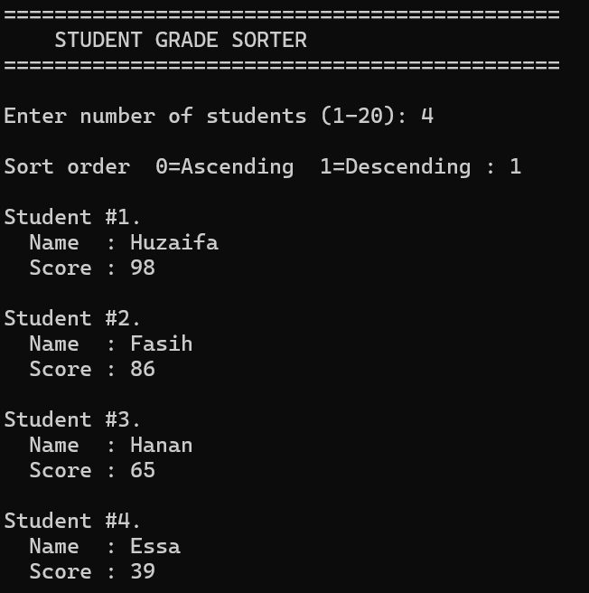

6.2 Detailed Report Output

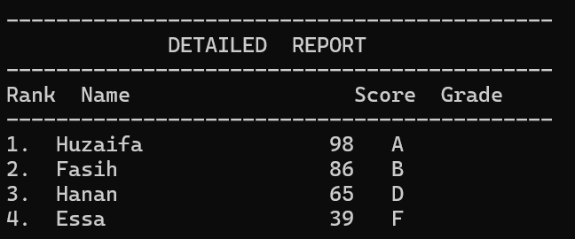

6.3 Statistics

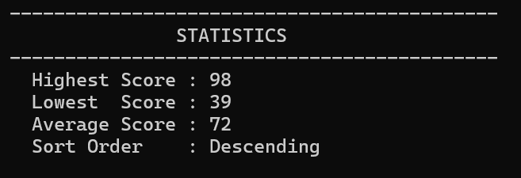

7. Conclusion
This project successfully implements a complete student grade management system in x86 Assembly language. Starting from a basic bubble sort on a hardcoded array, the program was expanded into a fully interactive application with eight distinct functional modules.
Building this in assembly provided direct exposure to how computers actually manage data at the lowest level — every string operation, every loop, and every comparison is explicit and intentional. Challenges like the A2075 jump-too-far error and the parallel array swap problem required a genuine understanding of how the CPU encodes instructions and manages memory, which is the core learning outcome of an assembly language course.
The final program handles all edge cases (invalid input, single-student input, perfect scores), produces clean aligned output, and is structured into logical, reusable procedures — demonstrating that good software design principles apply even at the assembly level.

Modules Implemented
- User Input with validation (count, names, scores, sort order)
- Bubble Sort — Ascending and Descending
- Student Names stored and sorted alongside scores
- Detailed Ranked Report with column-aligned output
- Highest Score and Lowest Score
- Average Score (integer division)
- Error handling and re-prompt loops for all inputs

